

**cDOT 9.1P12 Upgrade from 9.1P7**

**Authors:** Ian Daniel

**Contributors: Craig Goettig**, Joel Edstrom, Ken Zola, Adrian Wicks, Dan Niedere

**Document Version:** V0.4

**Date:** April 2018

Status: Draft

**CONFIDENTIAL INFORMATION**

This document contains information proprietary to Thomson Reuters and may not be reproduced, disclosed or used in whole or part without express permission of Thomson Reuters.

© Thomson Reuters 2018

Contents

1 Introduction 3

1.1 Management Summary 3

1.2 Change History 3

1.3 Distribution List 4

1.4 Glossary 4

2 Pre-Upgrade Process (9.1P7) 5

2.1 Description 5

2.2 Tasks 5

2.2.1 Obtain The Correct ONTAP Versions And Make them Available Via HTTP 5

2.2.2 Check For ISCSI 5

2.2.3 Check For Incorrectly Built ISCSI Vservers 5

2.2.4 Check For Hardware Issues 8

2.2.5 Check DNS Servers 17

2.2.6 Check/Update DQP 17

2.2.7 Check/Update Disk Firmware 17

2.2.8 Check/Update Shelf Firmware 18

2.2.9 Reboot Service Processors 18

2.2.10 Check CN1610 Switches (If Used) 19

2.2.1 Check Cisco 3132 Switches (If Used) 19

2.2.2 Generate An Upgrade Advisor 20

2.2.3 Check Upgrade Advisor 21

3 Upgrade Process (9.1P12) 22

3.1 Description 22

3.2 Tasks 22

3.2.1 Download Code Onto All Nodes 22

3.2.2 Verify Storage Health 22

3.2.3 Check All Aggregates Are Online 22

3.2.4 Check All Aggregates Have Enough Space 22

3.2.5 Check Auto Revert Settings 23

3.2.6 Enable Auto Revert If Required 23

3.2.7 Check All Volumes Are Online 23

3.2.8 Check All Volumes Have Enough Space 24

3.2.9 Check For Running Jobs 24

3.2.10 Check Number of Snapshots is Less Than 20000 Per Node 24

3.2.11 Quiesce SnapMirrors If Used 24

3.2.12 Check auto-giveback is disabled 25

3.2.13 Disable Auto-Giveback If Required On All Nodes 25

3.2.14 Disable Case Generation Prior To Upgrade For 4 Hours 25

3.2.15 Terminate CIFS Sessions 25

3.2.16 Validate Upgrade Package 26

3.2.17 Estimate Upgrade Time 26

3.2.18 Perform Upgrade 26

3.2.19 Checking Upgrade Progress 27

4 Post-Upgrade Process (9.1P12) 28

4.1 Description 28

4.1.1 Resume SnapMirror If Used 28

4.1.2 Ensure Auto-Giveback Is Still Disabled 29

4.1.3 Disable Auto-Giveback If Required 29

4.1.4 RE-Home LIFs 29

4.1.5 Disable Auto-Revert 29

5 Scripts 30

5.1 Description 30

5.1.1 Enable/Disable Auto Revert 30

5.1.2 Check DNS Accessible Pre-Upgrade 30

# Introduction

## Management Summary

This document details the process used to upgrade cDOT from 9.1P7 to 9.1P12

## Change History

|  |  |  |  |
| --- | --- | --- | --- |
| **Ver** | **Date** | **Author** | **Key Changes** |
| 0.1 | April 2018 | Ian Daniel | Initial Version |
| 0.2 | April 2018 | Ian Daniel | Added check for bad ISCSI builds |
| 0.3 | April 2018 | Ian Daniel | Modified pre-checks |
| 0.4 | April 2018 | Ian Daniel | Modified example text |
|  |  |  |  |
|  |  |  |  |
|  |  |  |  |
|  |  |  |  |
|  |  |  |  |
|  |  |  |  |
|  |  |  |  |
|  |  |  |  |
|  |  |  |  |
|  |  |  |  |
|  |  |  |  |
|  |  |  |  |

## Distribution List

|  |  |
| --- | --- |
| **Name** | **Role** |
| Storage Engineering | Reviewer |
| Storage Delivery | Reviewer |
| Storage Architecture | Reviewer |

## Glossary

|  |  |
| --- | --- |
| **Term** | **Definition** |
| cDOT | clustered Data ONTAP |
| Vserver | A logical storage virtual server, also known as a Storage Virtual Machine (SVM), which contains LIFs, Volumes, and configuration information such as access control details. |
| LIF | Logical Interface – a cDOT logical network interface with an IP address, assigned to a single Vserver. |
| CIFS | Short for Common Internet File System, a protocol that defines a standard for remote file access using millions of computers at a time. With CIFS, users with different platforms and computers can share files without having to install new software. |
| SMB | Short for Server Message Block, a message format used by DOS and Windows to share files, directories and devices. |
| NFS | A distributed file system protocol originally developed by Sun Microsystems in 1984, allowing a user on a client computer to access files over a computer network much like local storage is accessed. |

# Pre-Upgrade Process (9.1P7)

## Description

Prior to upgrading a cluster to 9.1P12 you first need to perform a number of tasks in order to ensure the upgrade goes smoothly.

## Tasks

The following tasks are carried out pre-upgrade.

### ****Obtain The Correct ONTAP Versions And Make them Available Via HTTP****

The version of ONTAP being used for the upgrade is 9.1P12 and is available here:

<http://mysupport.netapp.com/NOW/download/software/ontap/9.1P12/download.cgi>

### ****Check For ISCSI****

At this time ISCSI is approved for use in TR on cDOT 8.3.x or 9.1P12 as long as the versions of SD and SMSQL are correct. Please ensure all versions of software are correct before upgrading a cluster with ISCSI present..

eg-cps-clsp-e01::> lun show -vserver *

There are no entries matching your query.

If there are LUNs present you will see output like this.

eg-si-clsn-e01::> lun show -vserver *

Vserver Path State Mapped Type Size

--------- ------------------------------- ------- -------- -------- --------

ciststjms-e0001

/vol/iscsitest01/lun/testlun01 online unmapped windows 20.00GB

orprod-iscsi-01

/vol/cb0000_wi_15142_05_info_snap/luns/snapinfo

online mapped windows 10.00GB

orprod-iscsi-01

/vol/cb0000_wi_15142_05_tsys_nosnap/luns/sysdb

online mapped windows 20.00GB

### ****Check For Incorrectly Built ISCSI Vservers****

There have been instances of ISCSI vservers being incorrectly built with LIFs on only one node of a HA pair or on completely different HA pairs. Check for this using the following command:

net int show -data-protocol iscsi -fields home-node ,home-port ,vserver ,address,is-home

**Examples**

ln-cis-clsn-d01::*> net int show -data-protocol iscsi -fields home-node ,home-port ,vserver ,address,is-home

(network interface show)

vserver lif home-node home-port is-home address

------------- ------------------- ------------------- --------- ------- -------------

cisclnt-d0014 cisclnt-d0014-lif01 ln-cis-clsn-d01-l01 a0a-2032 true 10.235.16.117

cisclnt-d0014 cisclnt-d0014-lif02 ln-cis-clsn-d01-l02 a0a-2032 true 10.235.16.118

cisclnt-d0015 cisclnt-d0015-lif01 ln-cis-clsn-d01-h01 a0a-2032 true 10.235.16.120

cisclnt-d0015 cisclnt-d0015-lif02 ln-cis-clsn-d01-h01 a0a-2032 true 10.235.16.121

cisclnt-d0019 cisclnt-d0019-lif01 ln-cis-clsn-d01-l01 a0a-2032 true 10.235.16.135

cisclnt-d0019 cisclnt-d0019-lif02 ln-cis-clsn-d01-l02 a0a-2032 true 10.235.16.136

cisclnt-d0031 cisclnt-d0031-lif01 ln-cis-clsn-d01-h01 a0a-2032 true 10.235.16.167

cisclnt-d0031 cisclnt-d0031-lif02 ln-cis-clsn-d01-h02 a0a-2032 true 10.235.16.168

cisclnt-d0032 cisclnt-d0032-lif01 ln-cis-clsn-d01-h01 a0a-2032 true 10.235.16.169

cisclnt-d0032 cisclnt-d0032-lif02 ln-cis-clsn-d01-h02 a0a-2032 true 10.235.16.170

cisclnt-d0034 cisclnt-d0034-lif01 ln-cis-clsn-d01-h02 a0a-2032 true 10.235.16.172

cisclnt-d0034 cisclnt-d0034-lif02 ln-cis-clsn-d01-h01 a0a-2032 true 10.235.16.173

cisclnt-d0062 cisclnt-d0062-lif01 ln-cis-clsn-d01-l01 a0a-2032 true 10.235.16.222

cisclnt-d0062 cisclnt-d0062-lif02 ln-cis-clsn-d01-l02 a0a-2032 true 10.235.16.223

14 entries were displayed.

pl-cis-clsp-p01::> net int show -data-protocol iscsi -fields home-node ,home-port ,vserver ,address,is-home

(network interface show)

vserver lif home-node home-port is-home address

------------- ------------------- ------------------- --------- ------- ------------

cisclnt-p0002 cisclnt-p0002-lif01 pl-cis-clsp-p01-h01 a0a-2050 true 10.184.61.88

cisclnt-p0002 cisclnt-p0002-lif02 pl-cis-clsp-p01-h02 a0a-2050 true 10.184.61.89

cisclnt-p0012 cisclnt-p0012-lif01 pl-cis-clsp-p01-l01 a0a-2050 true 10.184.61.97

cisclnt-p0012 cisclnt-p0012-lif02 pl-cis-clsp-p01-l02 a0a-2050 true 10.184.61.98

cisclnt-p0013 cisclnt-p0013-lif01 pl-cis-clsp-p01-l01 a0a-2050 true 10.184.61.100

cisclnt-p0013 cisclnt-p0013-lif02 pl-cis-clsp-p01-l02 a0a-2050 true 10.184.61.101

cisclnt-p0014 cisclnt-p0014-lif01 pl-cis-clsp-p01-l01 a0a-2050 true 10.184.61.103

cisclnt-p0014 cisclnt-p0014-lif02 pl-cis-clsp-p01-l02 a0a-2050 true 10.184.61.104

cisclnt-p0015 cisclnt-p0015-lif01 pl-cis-clsp-p01-l01 a0a-2050 true 10.184.61.106

cisclnt-p0015 cisclnt-p0015-lif02 pl-cis-clsp-p01-l02 a0a-2050 true 10.184.61.107

cisclnt-p0016 cisclnt-p0016-lif01 pl-cis-clsp-p01-l01 a0a-2050 true 10.184.61.109

cisclnt-p0016 cisclnt-p0016-lif02 pl-cis-clsp-p01-l02 a0a-2050 true 10.184.61.110

cisclnt-p0017 cisclnt-p0017-lif01 pl-cis-clsp-p01-l01 a0a-2050 true 10.184.61.112

cisclnt-p0017 cisclnt-p0017-lif02 pl-cis-clsp-p01-l02 a0a-2050 true 10.184.61.113

cisclnt-p0018 cisclnt-p0018-lif01 pl-cis-clsp-p01-l01 a0a-2050 true 10.184.61.115

cisclnt-p0018 cisclnt-p0018-lif02 pl-cis-clsp-p01-l02 a0a-2050 true 10.184.61.116

cisclnt-p0019 cisclnt-p0019-lif01 pl-cis-clsp-p01-l01 a0a-2050 true 10.184.61.118

cisclnt-p0019 cisclnt-p0019-lif02 pl-cis-clsp-p01-l02 a0a-2050 true 10.184.61.119

cisclnt-p0020 cisclnt-p0020-lif01 pl-cis-clsp-p01-l01 a0a-2050 true 10.184.61.121

cisclnt-p0020 cisclnt-p0020-lif02 pl-cis-clsp-p01-l02 a0a-2050 true 10.184.61.122

cisclnt-p0021 cisclnt-p0021-lif01 pl-cis-clsp-p01-l01 a0a-2050 true 10.184.61.124

cisclnt-p0021 cisclnt-p0021-lif02 pl-cis-clsp-p01-l02 a0a-2050 true 10.184.61.125

cisclnt-p0022 cisclnt-p0022-lif01 pl-cis-clsp-p01-l01 a0a-2050 true 10.184.61.127

cisclnt-p0022 cisclnt-p0022-lif02 pl-cis-clsp-p01-l02 a0a-2050 true 10.184.61.128

cisclnt-p0023 cisclnt-p0023-lif01 pl-cis-clsp-p01-l02 a0a-2050 true 10.184.61.131

cisclnt-p0023 cisclnt-p0023-lif02 pl-cis-clsp-p01-l01 a0a-2050 true 10.184.61.132

cisclnt-p0024 cisclnt-p0024-lif01 pl-cis-clsp-p01-l01 a0a-2050 true 10.184.61.141

cisclnt-p0024 cisclnt-p0024-lif02 pl-cis-clsp-p01-l02 a0a-2050 true 10.184.61.142

cisclnt-p0025 cisclnt-p0025-lif01 pl-cis-clsp-p01-l02 a0a-2050 true 10.184.61.144

cisclnt-p0025 cisclnt-p0025-lif02 pl-cis-clsp-p01-h02 a0a-2050 true 10.184.61.145

cisclnt-p0027 cisclnt-p0027-lif01 pl-cis-clsp-p01-l02 a0a-2050 true 10.184.61.150

cisclnt-p0027 cisclnt-p0027-lif02 pl-cis-clsp-p01-l01 a0a-2050 true 10.184.61.151

cisclnt-p0028 cisclnt-p0028-lif01 pl-cis-clsp-p01-l01 a0a-2050 true 10.184.61.152

cisclnt-p0028 cisclnt-p0028-lif02 pl-cis-clsp-p01-l02 a0a-2050 true 10.184.61.153

cisclnt-p0029 cisclnt-p0029-lif01 pl-cis-clsp-p01-l02 a0a-2050 true 10.184.61.157

cisclnt-p0029 cisclnt-p0029-lif02 pl-cis-clsp-p01-l01 a0a-2050 true 10.184.61.158

cisclnt-p0030 cisclnt-p0030-lif01 pl-cis-clsp-p01-l02 a0a-2050 true 10.184.61.160

cisclnt-p0030 cisclnt-p0030-lif02 pl-cis-clsp-p01-l01 a0a-2050 true 10.184.61.161

cisclnt-p0031 cisclnt-p0031-lif01 pl-cis-clsp-p01-l02 a0a-2050 true 10.184.61.163

cisclnt-p0031 cisclnt-p0031-lif02 pl-cis-clsp-p01-l01 a0a-2050 true 10.184.61.164

cisclnt-p0032 cisclnt-p0032-lif01 pl-cis-clsp-p01-l02 a0a-2050 true 10.184.61.166

cisclnt-p0032 cisclnt-p0032-lif02 pl-cis-clsp-p01-l02 a0a-2050 true 10.184.61.167

cisclnt-p0035 cisclnt-p0035-lif01 pl-cis-clsp-p01-l01 a0a-2050 true 10.184.61.171

cisclnt-p0035 cisclnt-p0035-lif02 pl-cis-clsp-p01-l02 a0a-2050 true 10.184.61.172

cisclnt-p0036 cisclnt-p0036-lif01 pl-cis-clsp-p01-l01 a0a-2050 true 10.184.61.174

cisclnt-p0036 cisclnt-p0036-lif02 pl-cis-clsp-p01-l02 a0a-2050 true 10.184.61.176

cisclnt-p0038 cisclnt-p0038-lif01 pl-cis-clsp-p01-l01 a0a-2050 true 10.184.61.179

cisclnt-p0038 cisclnt-p0038-lif02 pl-cis-clsp-p01-l02 a0a-2050 true 10.184.61.180

cisclnt-p0039 cisclnt-p0039-lif01 pl-cis-clsp-p01-l01 a0a-2050 true 10.184.61.182

cisclnt-p0039 cisclnt-p0039-lif02 pl-cis-clsp-p01-l02 a0a-2050 true 10.184.61.183

cisclnt-p0041 cisclnt-p0041-lif01 pl-cis-clsp-p01-l01 a0a-2050 true 10.184.61.209

cisclnt-p0041 cisclnt-p0041-lif02 pl-cis-clsp-p01-l02 a0a-2050 true 10.184.61.194

cisclnt-p0042 cisclnt-p0042-lif01 pl-cis-clsp-p01-l01 a0a-2050 true 10.184.61.196

cisclnt-p0042 cisclnt-p0042-lif02 pl-cis-clsp-p01-l02 a0a-2050 true 10.184.61.197

cisclnt-p0043 cisclnt-p0043-lif01 pl-cis-clsp-p01-l01 a0a-2050 true 10.184.61.200

cisclnt-p0043 cisclnt-p0043-lif02 pl-cis-clsp-p01-l02 a0a-2050 true 10.184.61.201

cisclnt-p0044 cisclnt-p0044-lif01 pl-cis-clsp-p01-l01 a0a-2050 true 10.184.61.203

vserver lif home-node home-port is-home address

------------- ------------------- ------------------- --------- ------- ------------

cisclnt-p0044 cisclnt-p0044-lif02 pl-cis-clsp-p01-l02 a0a-2050 true 10.184.61.204

cisclnt-p0045 cisclnt-p0045-lif01 pl-cis-clsp-p01-l01 a0a-2050 true 10.184.61.208

cisclnt-p0045 cisclnt-p0045-lif02 pl-cis-clsp-p01-l02 a0a-2050 true 10.184.61.207

cisclnt-p0047 cisclnt-p0047-lif01 pl-cis-clsp-p01-l01 a0a-2050 true 10.184.61.213

cisclnt-p0047 cisclnt-p0047-lif02 pl-cis-clsp-p01-l02 a0a-2050 true 10.184.61.214

cisclnt-p0048 cisclnt-p0048-lif01 pl-cis-clsp-p01-h01 a0a-2050 true 10.184.61.216

cisclnt-p0048 cisclnt-p0048-lif02 pl-cis-clsp-p01-h02 a0a-2050 true 10.184.61.217

cisclnt-p0049 cisclnt-p0049-lif01 pl-cis-clsp-p01-l01 a0a-2050 true 10.184.61.219

cisclnt-p0049 cisclnt-p0049-lif02 pl-cis-clsp-p01-l02 a0a-2050 true 10.184.61.221

cisclnt-p0050 cisclnt-p0050-lif01 pl-cis-clsp-p01-h01 a0a-2050 true 10.184.61.222

cisclnt-p0050 cisclnt-p0050-lif02 pl-cis-clsp-p01-h02 a0a-2050 true 10.184.61.223

cisclnt-p0056 cisclnt-p0056-lif01 pl-cis-clsp-p01-l02 a0a-2050 true 10.184.61.250

cisclnt-p0056 cisclnt-p0056-lif02 pl-cis-clsp-p01-l01 a0a-2050 true 10.184.61.251

cisclnt-p0059 cisclnt-p0059-lif01 pl-cis-clsp-p01-h02 a0a-2054 true 10.184.114.2

cisclnt-p0059 cisclnt-p0059-lif02 pl-cis-clsp-p01-h01 a0a-2054 true 10.184.114.3

cisclnt-p0061 cisclnt-p0061-lif01 pl-cis-clsp-p01-l02 a0a-2054 true 10.184.114.6

cisclnt-p0061 cisclnt-p0061-lif02 pl-cis-clsp-p01-l01 a0a-2054 true 10.184.114.7

cisclnt-p0065 cisclnt-p0065-lif01 pl-cis-clsp-p01-l01 a0a-2054 true 10.184.114.12

cisclnt-p0065 cisclnt-p0065-lif02 pl-cis-clsp-p01-l02 a0a-2054 true 10.184.114.13

cisclnt-p0066 cisclnt-p0066-lif01 pl-cis-clsp-p01-h01 a0a-2054 true 10.184.114.15

cisclnt-p0066 cisclnt-p0066-lif02 pl-cis-clsp-p01-h02 a0a-2054 true 10.184.114.16

cisclnt-p0067 cisclnt-p0067-lif01 pl-cis-clsp-p01-h01 a0a-2054 true 10.184.114.18

cisclnt-p0067 cisclnt-p0067-lif02 pl-cis-clsp-p01-h02 a0a-2054 true 10.184.114.19

cisclnt-p0071 cisclnt-p0071-lif01 pl-cis-clsp-p01-l01 a0a-2054 true 10.184.114.24

cisclnt-p0071 cisclnt-p0071-lif02 pl-cis-clsp-p01-l02 a0a-2054 true 10.184.114.25

cisclnt-p0076 cisclnt-p0076-lif01 pl-cis-clsp-p01-h02 a0a-2054 true 10.184.114.42

cisclnt-p0076 cisclnt-p0076-lif02 pl-cis-clsp-p01-h01 a0a-2054 true 10.184.114.43

cisclnt-p0078 cisclnt-p0078-lif01 pl-cis-clsp-p01-l01 a0a-2054 true 10.184.114.46

cisclnt-p0078 cisclnt-p0078-lif02 pl-cis-clsp-p01-l02 a0a-2054 true 10.184.114.47

cisclnt-p0095 cisclnt-p0095-lif01 pl-cis-clsp-p01-l01 a0a-2054 true 10.184.114.78

cisclnt-p0095 cisclnt-p0095-lif02 pl-cis-clsp-p01-l02 a0a-2054 true 10.184.114.79

cisprod-p0007 cisprod-p0007-lif01 pl-cis-clsp-p01-h01 a0a-2050 true 10.184.61.85

cisprod-p0007 cisprod-p0007-lif02 pl-cis-clsp-p01-h02 a0a-2050 true 10.184.61.86

cisprod-p0022 cisprod-p0022-lif01 pl-cis-clsp-p01-h01 a0a-2050 true 10.184.61.226

cisprod-p0022 cisprod-p0022-lif02 pl-cis-clsp-p01-h02 a0a-2050 true 10.184.61.227

cisprod-p0023 cisprod-p0023-lif01 pl-cis-clsp-p01-h01 a0a-2050 true 10.184.61.229

cisprod-p0023 cisprod-p0023-lif02 pl-cis-clsp-p01-h02 a0a-2050 true 10.184.61.230

cisprod-p0025 cisprod-p0025-lif01 pl-cis-clsp-p01-h01 a0a-2050 true 10.184.61.233

cisprod-p0025 cisprod-p0025-lif02 pl-cis-clsp-p01-h02 a0a-2050 true 10.184.61.234

cisprod-p0030 cisprod-p0030-lif01 pl-cis-clsp-p01-h01 a0a-2050 true 10.184.61.244

cisprod-p0030 cisprod-p0030-lif02 pl-cis-clsp-p01-h02 a0a-2050 true 10.184.61.245

cisprod-p0033 cisprod-p0033-lif01 pl-cis-clsp-p01-h01 a0a-2054 true 10.184.114.27

cisprod-p0033 cisprod-p0033-lif02 pl-cis-clsp-p01-h02 a0a-2054 true 10.184.114.28

cisprod-p0034 cisprod-p0034-lif01 pl-cis-clsp-p01-h01 a0a-2054 true 10.184.114.30

cisprod-p0034 cisprod-p0034-lif02 pl-cis-clsp-p01-h02 a0a-2054 true 10.184.114.31

cisprod-p0036 cisprod-p0036-lif01 pl-cis-clsp-p01-h01 a0a-2054 true 10.184.114.35

cisprod-p0036 cisprod-p0036-lif02 pl-cis-clsp-p01-h02 a0a-2054 true 10.184.114.36

104 entries were displayed.

### ****Check For Hardware Issues****

Check for disk failures, shelf issues etc.

::*> system node environment sensors show

Node Sensor State Value/Units Crit-Low Warn-Low Warn-Hi Crit-Hi

---- --------------------- ------ ----------- -------- -------- ------- -------

eg-si-clsn-e01-h01

Fan1 normal

GOOD

Fan2 normal

GOOD

Fan3 normal

GOOD

PSU1 normal

GOOD

PSU2 normal

GOOD

CPU0 Temp Margin normal

-63 C - - -5 0

In Flow Temp normal

28 C 0 10 50 56

Out Flow Temp normal

42 C 0 10 64 71

PCI Riser_R Temp normal

31 C 0 10 49 57

Smart Bat Temp normal

36 C 0 10 58 65

CPU0 Error normal

NORMAL

CPU0 Therm Trip normal

NORMAL

CPU0 Hot normal

NORMAL

Memory0 Hot normal

NORMAL

PCH Hot normal

NORMAL

P5V STBY normal

5002 mV 4245 4343 5660 5807

P3.3V STBY normal

3312 mV 2960 3040 3568 3664

P1.8V STBY normal

1794 mV 1629 1658 1949 1969

P1.2V STBY normal

1193 mV 1086 1105 1299 1319

P0.9V STBY normal

882 mV 805 853 950 999

P5V normal

5026 mV 4245 4343 5660 5807

P3.3V normal

3280 mV 2960 3040 3568 3664

Press <space> to page down, <return> for next line, or 'q' to quit...

::*> node run -node * environment status chassis list-sensors

4 entries were acted on.

Node: eg-si-clsn-e01-h01

Sensor Name State Current Critical Warning Warning Critical

Reading Low Low High High

-------------------------------------------------------------------------------------------------

Fan1 GOOD

Fan2 GOOD

Fan3 GOOD

PSU1 GOOD

PSU2 GOOD

CPU0 Temp Margin normal -68 C -- -- -5 C 0 C

In Flow Temp normal 24 C 0 C 10 C 50 C 56 C

Out Flow Temp normal 37 C 0 C 10 C 64 C 71 C

PCI Riser_R Temp normal 26 C 0 C 10 C 49 C 57 C

Smart Bat Temp normal 31 C 0 C 10 C 58 C 65 C

CPU0 Error NORMAL

CPU0 Therm Trip NORMAL

CPU0 Hot NORMAL

Memory0 Hot NORMAL

PCH Hot NORMAL

P5V STBY normal 5002 mV 4245 mV 4343 mV 5660 mV 5807 mV

P3.3V STBY normal 3312 mV 2960 mV 3040 mV 3568 mV 3664 mV

P1.8V STBY normal 1794 mV 1629 mV 1658 mV 1949 mV 1969 mV

P1.2V STBY normal 1193 mV 1086 mV 1105 mV 1299 mV 1319 mV

P0.9V STBY normal 882 mV 805 mV 853 mV 950 mV 999 mV

P5V normal 5050 mV 4245 mV 4343 mV 5660 mV 5807 mV

P3.3V normal 3280 mV 2960 mV 3040 mV 3568 mV 3664 mV

PVDDQ DDR3 AB normal 1338 mV 9 mV 19 mV 2454 mV 2463 mV

PVTT DDR3 AB normal 669 mV 9 mV 19 mV 2454 mV 2463 mV

PVCCP CPU0 normal 960 mV 9 mV 19 mV 2454 mV 2463 mV

PVDDQ DDR3 CD normal 1328 mV 9 mV 19 mV 2454 mV 2463 mV

P12V CPU normal 11875 mV 0 mV -- -- 31875 mV

P12V CPU Curr normal 3500 mA 0 mA -- -- 63750 mA

P12V Sys normal 11875 mV 0 mV -- -- 31875 mV

P12V Sys Curr normal 10250 mA 0 mA -- -- 63750 mA

P12V STBY normal 11875 mV 0 mV -- -- 31875 mV

P12V STBY Curr normal 384 mA 0 mA -- -- 4080 mA

P5V STBY SQ normal 5000 mV 0 mV -- -- 31875 mV

P5V STBY Curr normal 75 mA -- -- -- 1275 mA

Sysfan1 Present PRESENT

Sysfan1 Fault OK

Sysfan1 F1 Speed normal 2760 RPM 1470 RPM 1560 RPM -- --

Sysfan1 F2 Speed normal 2760 RPM 1470 RPM 1560 RPM -- --

Sysfan2 Present PRESENT

Sysfan2 Fault OK

Sysfan2 F1 Speed normal 2820 RPM 1470 RPM 1560 RPM -- --

Sysfan2 F2 Speed normal 2820 RPM 1470 RPM 1560 RPM -- --

Sysfan3 Present PRESENT

Sysfan3 Fault OK

Sysfan3 F1 Speed normal 2760 RPM 1470 RPM 1560 RPM -- --

Sysfan3 F2 Speed normal 2760 RPM 1470 RPM 1560 RPM -- --

PSU1 Present PRESENT

PSU1 Temp normal 17 C 0 C 5 C 50 C 60 C

PSU1 Curr normal 15000 mA -- -- -- --

PSU1 Fan1 Speed normal 13500 RPM 4500 RPM 4600 RPM -- --

PSU1 Fan1 Fault OK

PSU1 Fan2 Speed normal 9900 RPM 4500 RPM 4600 RPM -- --

PSU1 Fan2 Fault OK

PSU1 Pwr In OK OK

PSU1 Pwr Out OK OK

PSU1 FAULT OK

PSU1 Input Type AC_220V

PSU1 Over Temp OK

PSU1 Over Volt OK

PSU1 Over Curr OK

PSU2 Present PRESENT

PSU2 Temp normal 17 C 0 C 5 C 50 C 60 C

PSU2 Curr normal 15000 mA -- -- -- --

PSU2 Fan1 Speed normal 10300 RPM 4500 RPM 4600 RPM -- --

PSU2 Fan1 Fault OK

PSU2 Fan2 Speed normal 9200 RPM 4500 RPM 4600 RPM -- --

PSU2 Fan2 Fault OK

PSU2 Pwr In OK OK

PSU2 Pwr Out OK OK

PSU2 FAULT OK

PSU2 Input Type AC_220V

PSU2 Over Temp OK

PSU2 Over Volt OK

PSU2 Over Curr OK

Bat Present PRESENT

Bat Temp normal 20 C 0 C 5 C 53 C 58 C

Bat Volt normal 7900 mV 5500 mV 5600 mV 8500 mV 8600 mV

Bat Curr normal 0 mA -4000 mA -40 mA 1200 mA 1520 mA

Bat Rem Cap normal 3584 mA*hr -- -- -- --

Bat Full Cap normal 4096 mA*hr -- -- -- --

Bat Charge Curr normal 0 mA -- -- 2200 mA 2300 mA

Bat Charge Volt normal 8200 mV -- -- 8900 mV 9000 mV

Bat Initial FCC normal 4200 mA*hr -- -- -- --

Bat Dstg Cycles normal 51 cycles 2 cycles 5 cycles -- --

Bat Power Fault GOOD

Bat Charge FET ON

Bat Dcharge FET ON

Partner Ctrl Pre PRESENT

SP Status IPMI_HB_OK

Usbmon Status OK

Usbmon Pres PRESENT

Node: eg-si-clsn-e01-h02

Sensor Name State Current Critical Warning Warning Critical

Reading Low Low High High

-------------------------------------------------------------------------------------------------

Fan1 GOOD

Fan2 GOOD

Fan3 GOOD

PSU1 GOOD

PSU2 GOOD

CPU0 Temp Margin normal -70 C -- -- -5 C 0 C

In Flow Temp normal 24 C 0 C 10 C 50 C 56 C

Out Flow Temp normal 37 C 0 C 10 C 64 C 71 C

PCI Riser_R Temp normal 26 C 0 C 10 C 49 C 57 C

Smart Bat Temp normal 31 C 0 C 10 C 58 C 65 C

CPU0 Error NORMAL

CPU0 Therm Trip NORMAL

CPU0 Hot NORMAL

Memory0 Hot NORMAL

PCH Hot NORMAL

P5V STBY normal 5002 mV 4245 mV 4343 mV 5660 mV 5807 mV

P3.3V STBY normal 3312 mV 2960 mV 3040 mV 3568 mV 3664 mV

P1.8V STBY normal 1794 mV 1629 mV 1658 mV 1949 mV 1969 mV

P1.2V STBY normal 1193 mV 1086 mV 1105 mV 1299 mV 1319 mV

P0.9V STBY normal 882 mV 805 mV 853 mV 950 mV 999 mV

P5V normal 5050 mV 4245 mV 4343 mV 5660 mV 5807 mV

P3.3V normal 3280 mV 2960 mV 3040 mV 3568 mV 3664 mV

PVDDQ DDR3 AB normal 1338 mV 9 mV 19 mV 2454 mV 2463 mV

PVTT DDR3 AB normal 669 mV 9 mV 19 mV 2454 mV 2463 mV

PVCCP CPU0 normal 950 mV 9 mV 19 mV 2454 mV 2463 mV

PVDDQ DDR3 CD normal 1328 mV 9 mV 19 mV 2454 mV 2463 mV

P12V CPU normal 11875 mV 0 mV -- -- 31875 mV

P12V CPU Curr normal 3000 mA 0 mA -- -- 63750 mA

P12V Sys normal 11875 mV 0 mV -- -- 31875 mV

P12V Sys Curr normal 10250 mA 0 mA -- -- 63750 mA

P12V STBY normal 11875 mV 0 mV -- -- 31875 mV

P12V STBY Curr normal 384 mA 0 mA -- -- 4080 mA

P5V STBY SQ normal 4875 mV 0 mV -- -- 31875 mV

P5V STBY Curr normal 70 mA -- -- -- 1275 mA

Sysfan1 Present PRESENT

Sysfan1 Fault OK

Sysfan1 F1 Speed normal 2760 RPM 1470 RPM 1560 RPM -- --

Sysfan1 F2 Speed normal 2760 RPM 1470 RPM 1560 RPM -- --

Sysfan2 Present PRESENT

Sysfan2 Fault OK

Sysfan2 F1 Speed normal 2760 RPM 1470 RPM 1560 RPM -- --

Sysfan2 F2 Speed normal 2820 RPM 1470 RPM 1560 RPM -- --

Sysfan3 Present PRESENT

Sysfan3 Fault OK

Sysfan3 F1 Speed normal 2820 RPM 1470 RPM 1560 RPM -- --

Sysfan3 F2 Speed normal 2760 RPM 1470 RPM 1560 RPM -- --

PSU1 Present PRESENT

PSU1 Temp normal 17 C 0 C 5 C 50 C 60 C

PSU1 Curr normal 16000 mA -- -- -- --

PSU1 Fan1 Speed normal 10400 RPM 4500 RPM 4600 RPM -- --

PSU1 Fan1 Fault OK

PSU1 Fan2 Speed normal 9800 RPM 4500 RPM 4600 RPM -- --

PSU1 Fan2 Fault OK

PSU1 Pwr In OK OK

PSU1 Pwr Out OK OK

PSU1 FAULT OK

PSU1 Input Type AC_220V

PSU1 Over Temp OK

PSU1 Over Volt OK

PSU1 Over Curr OK

PSU2 Present PRESENT

PSU2 Temp normal 17 C 0 C 5 C 50 C 60 C

PSU2 Curr normal 15000 mA -- -- -- --

PSU2 Fan1 Speed normal 10200 RPM 4500 RPM 4600 RPM -- --

PSU2 Fan1 Fault OK

PSU2 Fan2 Speed normal 9600 RPM 4500 RPM 4600 RPM -- --

PSU2 Fan2 Fault OK

PSU2 Pwr In OK OK

PSU2 Pwr Out OK OK

PSU2 FAULT OK

PSU2 Input Type AC_220V

PSU2 Over Temp OK

PSU2 Over Volt OK

PSU2 Over Curr OK

Bat Present PRESENT

Bat Temp normal 20 C 0 C 5 C 53 C 58 C

Bat Volt normal 7900 mV 5500 mV 5600 mV 8500 mV 8600 mV

Bat Curr normal 0 mA -4000 mA -40 mA 1200 mA 1520 mA

Bat Rem Cap normal 3584 mA*hr -- -- -- --

Bat Full Cap normal 4096 mA*hr -- -- -- --

Bat Charge Curr normal 0 mA -- -- 2200 mA 2300 mA

Bat Charge Volt normal 8200 mV -- -- 8900 mV 9000 mV

Bat Initial FCC normal 4200 mA*hr -- -- -- --

Bat Dstg Cycles normal 53 cycles 2 cycles 5 cycles -- --

Bat Power Fault GOOD

Bat Charge FET ON

Bat Dcharge FET ON

Partner Ctrl Pre PRESENT

SP Status IPMI_HB_OK

Usbmon Status OK

Usbmon Pres PRESENT

Node: eg-si-clsn-e01-l03

Sensor Name State Current Critical Warning Warning Critical

Reading Low Low High High

-------------------------------------------------------------------------------------------------

Fan1 GOOD

Fan2 GOOD

Fan3 GOOD

PSU1 GOOD

PSU2 GOOD

CPU0 Temp Margin normal -71 C -- -- -5 C 0 C

In Flow Temp normal 21 C 0 C 10 C 50 C 56 C

Out Flow Temp normal 32 C 0 C 10 C 64 C 71 C

PCI Riser_R Temp normal 23 C 0 C 10 C 49 C 57 C

Smart Bat Temp normal 30 C 0 C 10 C 58 C 65 C

CPU0 Error NORMAL

CPU0 Therm Trip NORMAL

CPU0 Hot NORMAL

Memory0 Hot NORMAL

PCH Hot NORMAL

P5V STBY normal 4977 mV 4245 mV 4343 mV 5660 mV 5807 mV

P3.3V STBY normal 3296 mV 2960 mV 3040 mV 3568 mV 3664 mV

P1.8V STBY normal 1794 mV 1629 mV 1658 mV 1949 mV 1969 mV

P1.2V STBY normal 1193 mV 1086 mV 1105 mV 1299 mV 1319 mV

P0.9V STBY normal 882 mV 805 mV 853 mV 950 mV 999 mV

P5V normal 5050 mV 4245 mV 4343 mV 5660 mV 5807 mV

P3.3V normal 3280 mV 2960 mV 3040 mV 3568 mV 3664 mV

PVDDQ DDR3 AB normal 1338 mV 9 mV 19 mV 2454 mV 2463 mV

PVTT DDR3 AB normal 669 mV 9 mV 19 mV 2454 mV 2463 mV

PVCCP CPU0 normal 970 mV 9 mV 19 mV 2454 mV 2463 mV

PVDDQ DDR3 CD normal 1338 mV 9 mV 19 mV 2454 mV 2463 mV

P12V CPU normal 12000 mV 0 mV -- -- 31875 mV

P12V CPU Curr normal 2750 mA 0 mA -- -- 63750 mA

P12V Sys normal 11875 mV 0 mV -- -- 31875 mV

P12V Sys Curr normal 10500 mA 0 mA -- -- 63750 mA

P12V STBY normal 12000 mV 0 mV -- -- 31875 mV

P12V STBY Curr normal 384 mA 0 mA -- -- 4080 mA

P5V STBY SQ normal 4875 mV 0 mV -- -- 31875 mV

P5V STBY Curr normal 65 mA -- -- -- 1275 mA

Sysfan1 Present PRESENT

Sysfan1 Fault OK

Sysfan1 F1 Speed normal 2760 RPM 1470 RPM 1560 RPM -- --

Sysfan1 F2 Speed normal 2760 RPM 1470 RPM 1560 RPM -- --

Sysfan2 Present PRESENT

Sysfan2 Fault OK

Sysfan2 F1 Speed normal 2760 RPM 1470 RPM 1560 RPM -- --

Sysfan2 F2 Speed normal 2760 RPM 1470 RPM 1560 RPM -- --

Sysfan3 Present PRESENT

Sysfan3 Fault OK

Sysfan3 F1 Speed normal 2760 RPM 1470 RPM 1560 RPM -- --

Sysfan3 F2 Speed normal 2820 RPM 1470 RPM 1560 RPM -- --

PSU1 Present PRESENT

PSU1 Temp normal 21 C 0 C 5 C 50 C 60 C

PSU1 Curr normal 12000 mA -- -- -- --

PSU1 Fan1 Speed normal 16200 RPM 4500 RPM 4600 RPM -- --

PSU1 Fan1 Fault OK

PSU1 Fan2 Speed normal 15800 RPM 4500 RPM 4600 RPM -- --

PSU1 Fan2 Fault OK

PSU1 Pwr In OK OK

PSU1 Pwr Out OK OK

PSU1 FAULT OK

PSU1 Input Type AC_220V

PSU1 Over Temp OK

PSU1 Over Volt OK

PSU1 Over Curr OK

PSU2 Present PRESENT

PSU2 Temp normal 22 C 0 C 5 C 50 C 60 C

PSU2 Curr normal 15000 mA -- -- -- --

PSU2 Fan1 Speed normal 16200 RPM 4500 RPM 4600 RPM -- --

PSU2 Fan1 Fault OK

PSU2 Fan2 Speed normal 15800 RPM 4500 RPM 4600 RPM -- --

PSU2 Fan2 Fault OK

PSU2 Pwr In OK OK

PSU2 Pwr Out OK OK

PSU2 FAULT OK

PSU2 Input Type AC_220V

PSU2 Over Temp OK

PSU2 Over Volt OK

PSU2 Over Curr OK

Bat Present PRESENT

Bat Temp normal 20 C 0 C 5 C 53 C 58 C

Bat Volt normal 8000 mV 5500 mV 5600 mV 8500 mV 8600 mV

Bat Curr normal 0 mA -4000 mA -40 mA 1200 mA 1520 mA

Bat Rem Cap normal 3584 mA*hr -- -- -- --

Bat Full Cap normal 3840 mA*hr -- -- -- --

Bat Charge Curr normal 0 mA -- -- 2200 mA 2300 mA

Bat Charge Volt normal 8200 mV -- -- 8900 mV 9000 mV

Bat Initial FCC normal 4200 mA*hr -- -- -- --

Bat Dstg Cycles normal 52 cycles 2 cycles 5 cycles -- --

Bat Power Fault GOOD

Bat Charge FET ON

Bat Dcharge FET ON

Partner Ctrl Pre PRESENT

SP Status IPMI_HB_OK

Usbmon Status OK

Usbmon Pres PRESENT

Node: eg-si-clsn-e01-l04

Sensor Name State Current Critical Warning Warning Critical

Reading Low Low High High

-------------------------------------------------------------------------------------------------

Fan1 GOOD

Fan2 GOOD

Fan3 GOOD

PSU1 GOOD

PSU2 GOOD

CPU0 Temp Margin normal -72 C -- -- -5 C 0 C

In Flow Temp normal 21 C 0 C 10 C 50 C 56 C

Out Flow Temp normal 32 C 0 C 10 C 64 C 71 C

PCI Riser_R Temp normal 23 C 0 C 10 C 49 C 57 C

Smart Bat Temp normal 30 C 0 C 10 C 58 C 65 C

CPU0 Error NORMAL

CPU0 Therm Trip NORMAL

CPU0 Hot NORMAL

Memory0 Hot NORMAL

PCH Hot NORMAL

P5V STBY normal 5026 mV 4245 mV 4343 mV 5660 mV 5807 mV

P3.3V STBY normal 3296 mV 2960 mV 3040 mV 3568 mV 3664 mV

P1.8V STBY normal 1804 mV 1629 mV 1658 mV 1949 mV 1969 mV

P1.2V STBY normal 1193 mV 1086 mV 1105 mV 1299 mV 1319 mV

P0.9V STBY normal 892 mV 805 mV 853 mV 950 mV 999 mV

P5V normal 5050 mV 4245 mV 4343 mV 5660 mV 5807 mV

P3.3V normal 3296 mV 2960 mV 3040 mV 3568 mV 3664 mV

PVDDQ DDR3 AB normal 1338 mV 9 mV 19 mV 2454 mV 2463 mV

PVTT DDR3 AB normal 659 mV 9 mV 19 mV 2454 mV 2463 mV

PVCCP CPU0 normal 970 mV 9 mV 19 mV 2454 mV 2463 mV

PVDDQ DDR3 CD normal 1338 mV 9 mV 19 mV 2454 mV 2463 mV

P12V CPU normal 12000 mV 0 mV -- -- 31875 mV

P12V CPU Curr normal 2750 mA 0 mA -- -- 63750 mA

P12V Sys normal 11875 mV 0 mV -- -- 31875 mV

P12V Sys Curr normal 10500 mA 0 mA -- -- 63750 mA

P12V STBY normal 11875 mV 0 mV -- -- 31875 mV

P12V STBY Curr normal 400 mA 0 mA -- -- 4080 mA

P5V STBY SQ normal 5000 mV 0 mV -- -- 31875 mV

P5V STBY Curr normal 45 mA -- -- -- 1275 mA

Sysfan1 Present PRESENT

Sysfan1 Fault OK

Sysfan1 F1 Speed normal 2760 RPM 1470 RPM 1560 RPM -- --

Sysfan1 F2 Speed normal 2760 RPM 1470 RPM 1560 RPM -- --

Sysfan2 Present PRESENT

Sysfan2 Fault OK

Sysfan2 F1 Speed normal 2760 RPM 1470 RPM 1560 RPM -- --

Sysfan2 F2 Speed normal 2760 RPM 1470 RPM 1560 RPM -- --

Sysfan3 Present PRESENT

Sysfan3 Fault OK

Sysfan3 F1 Speed normal 2760 RPM 1470 RPM 1560 RPM -- --

Sysfan3 F2 Speed normal 2760 RPM 1470 RPM 1560 RPM -- --

PSU1 Present PRESENT

PSU1 Temp normal 22 C 0 C 5 C 50 C 60 C

PSU1 Curr normal 13000 mA -- -- -- --

PSU1 Fan1 Speed normal 16200 RPM 4500 RPM 4600 RPM -- --

PSU1 Fan1 Fault OK

PSU1 Fan2 Speed normal 15800 RPM 4500 RPM 4600 RPM -- --

PSU1 Fan2 Fault OK

PSU1 Pwr In OK OK

PSU1 Pwr Out OK OK

PSU1 FAULT OK

PSU1 Input Type AC_220V

PSU1 Over Temp OK

PSU1 Over Volt OK

PSU1 Over Curr OK

PSU2 Present PRESENT

PSU2 Temp normal 22 C 0 C 5 C 50 C 60 C

PSU2 Curr normal 15000 mA -- -- -- --

PSU2 Fan1 Speed normal 16200 RPM 4500 RPM 4600 RPM -- --

PSU2 Fan1 Fault OK

PSU2 Fan2 Speed normal 15800 RPM 4500 RPM 4600 RPM -- --

PSU2 Fan2 Fault OK

PSU2 Pwr In OK OK

PSU2 Pwr Out OK OK

PSU2 FAULT OK

PSU2 Input Type AC_220V

PSU2 Over Temp OK

PSU2 Over Volt OK

PSU2 Over Curr OK

Bat Present PRESENT

Bat Temp normal 19 C 0 C 5 C 53 C 58 C

Bat Volt normal 8000 mV 5500 mV 5600 mV 8500 mV 8600 mV

Bat Curr normal 0 mA -4000 mA -40 mA 1200 mA 1520 mA

Bat Rem Cap normal 3584 mA*hr -- -- -- --

Bat Full Cap normal 3840 mA*hr -- -- -- --

Bat Charge Curr normal 0 mA -- -- 2200 mA 2300 mA

Bat Charge Volt normal 8200 mV -- -- 8900 mV 9000 mV

Bat Initial FCC normal 4200 mA*hr -- -- -- --

Bat Dstg Cycles normal 52 cycles 2 cycles 5 cycles -- --

Bat Power Fault GOOD

Bat Charge FET ON

Bat Dcharge FET ON

Partner Ctrl Pre PRESENT

SP Status IPMI_HB_OK

Usbmon Status OK

Usbmon Pres PRESENT

### ****Check DNS Servers****

All vservers must have DNS configured and be able to contact those DNS servers prior to upgrade. This can be checked via autosupport risks on the NetApp Support Site. There is also a script you can use to test connectivity in section 8 of this document.

It is also advisable to ping the DNS servers using the vserver data LIF(s) to ensure they have connectivity.

**Example**

ln-cis-clsn-d01::> net ping -lif-owner svm977jvr -lif svm977jvr_lif -destination 10.52.132.65

  (network ping)

10.52.132.65 is alive

### ****Check/Update DQP****

Ensure DQP is the latest version.

::*> storage firmware download -node * -package-url http://10.220.179.83:8080/ONTAP/qual_devices.zip

Firmware download started.

Unpacking package contents.

Firmware downloaded.

Firmware download started.

Unpacking package contents.

Firmware downloaded.

Firmware download started.

Unpacking package contents.

Firmware downloaded.

Firmware download started.

Unpacking package contents.

Firmware downloaded.

4 entries were acted on.

### ****Check/Update Disk Firmware****

Ensure disk firmware is the latest version. This runs in background and may take a long time so is to be done well in advance.

::*> storage firmware download -node * -package-url http://10.220.179.83:8080/ONTAP/all.zip

Firmware download started.

Unpacking package contents.

Firmware downloaded.

Firmware download started.

Unpacking package contents.

Firmware downloaded.

Firmware download started.

Unpacking package contents.

Firmware downloaded.

Firmware download started.

Unpacking package contents.

Firmware downloaded.

4 entries were acted on.

### ****Check/Update Shelf Firmware****

Check the shelf firmware is up to date and if required update it.

ssh admin@CLUSTER storage shelf acp module show -fields firmware-version

Example

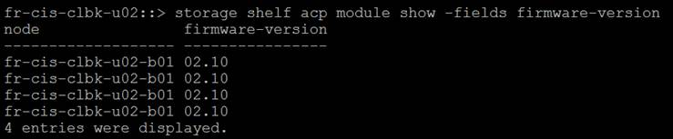

To update the relevant firmware use the following commands:

To download the latest shelf firmware package to all nodes in the cluster from a web server, use this command:

::*>**storage firmware download –node * -package-type all –package http://<**web-server**>/**path**/all_shelf_fw.zip**

To download an individual ACP firmware file to nodes in the cluster from a web server, use this command:

::*>**storage firmware download –node * -package-type acp -package http://<**web-server**>/**path**/<ACPP_type.fw_rev.AFW>.zip**

### ****Reboot Service Processors****

There is a bug that causes the SP to reboot the node if a certain number of days’ uptime is reached. Prior to upgrade reboot both SPs as a precautionary measure. **Once rebooted check both are accessible**.

::> system service-processor reboot-sp -node *

Note: If your console connection is through the SP, it will be disconnected.

Do you want to reboot the SP ? {y|n}: y

4 entries were acted on.

### ****Check CN1610 Switches (If Used)****

Switches need to be running a 1.2.x.x version of FASTPATH to support 8.3.x and above. If the switches are not running this version please upgrade them before upgrading ONTAP.

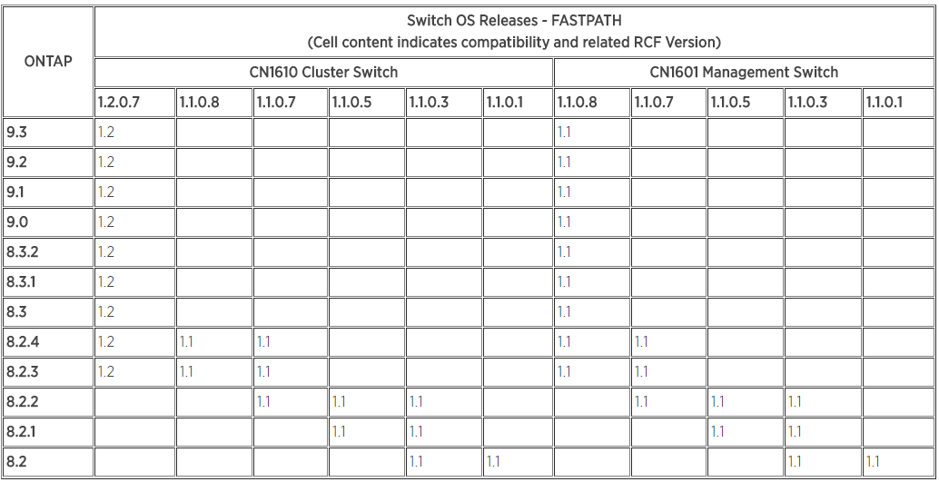

eg-si-clsn-e01::> system health cluster-switch show

Switch Type Address Model

--------------------------- ------------------ ---------------- ---------------

eag-nasor-clus1-switch-01 cluster-network 10.220.194.69 CN1610

Is Monitored: yes

Reason:

Software Version: 1.1.0.5

Version Source: ISDP

eag-nasor-clus1-switch-02 cluster-network 10.220.194.80 CN1610

Is Monitored: yes

Reason:

Software Version: 1.1.0.5

Version Source: ISDP

2 entries were displayed.

Note: SSH MUST be configured on the cluster switches prior to upgrade.

(CN1610) #ip ssh protocol 2

(CN1610) #configure

(CN1610) (Config)#crypto key generate dsa

(CN1610) (Config)#crypto key generate rsa

(CN1610) (Config)#exit

(CN1610) #ip ssh server enable

The switch upgrade process is here: [Switch Upgrade Process](https://theshare.thomsonreuters.com/sites/DCO_Storage/_layouts/WordViewer.aspx?id=/sites/DCO_Storage/Unified%20Storage%20DE%20Documents/NETAPP/Ontap%20CDOT%20Standards/ONTAP%20Upgrade%20Documents/9.1P7/cdot%20Switch%20Upgrade%20Process.docx&Source=https%3A%2F%2Ftheshare%2Ethomsonreuters%2Ecom%2Fsites%2FDCO%5FStorage%2FUnified%2520Storage%2520DE%2520Documents%2FForms%2FAllItems%2Easpx%3FRootFolder%3D%252Fsites%252FDCO%255FStorage%252FUnified%2520Storage%2520DE%2520Documents%252FNETAPP%252FOntap%2520CDOT%2520Standards%252FONTAP%2520Upgrade%2520Documents%252F9%252E1P7%26InitialTabId%3DRibbon%252EDocument%26VisibilityContext%3DWSSTabPersistence&DefaultItemOpen=1&DefaultItemOpen=1)

### ****Check Cisco 3132 Switches (If Used)****

Switches need to be running up to date supported firmware prior to upgrading. Please check the NetApp Support Site for firmware versions.

<https://mysupport.netapp.com/NOW/download/software/cm_switches/>

### ****Generate An Upgrade Advisor****

Upgrade advisors are based off ASUP data so once all issues are resolved with failover groups and interfaces please generate a new ASUP.

**Example**

::> autosupport invoke -node * -type all -message "9.1P7 UA SnapShot"

Active IQ is used to provide upgrade advisors now. Follow the process below:

Select the version and press Next

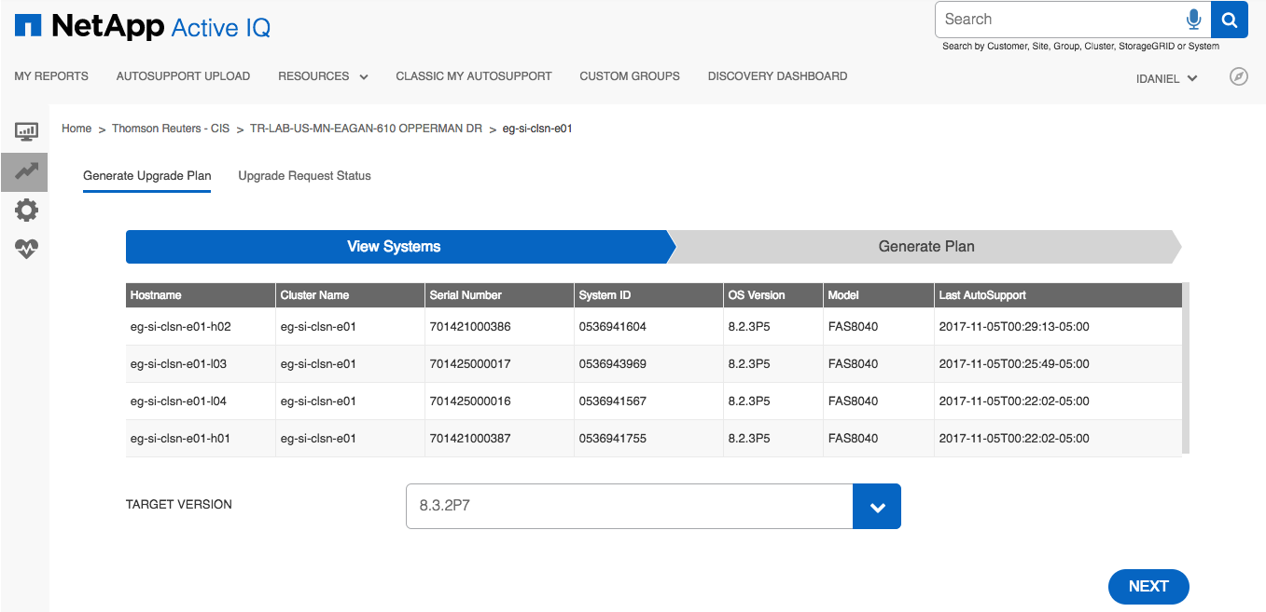

Select the correct options and press Generate

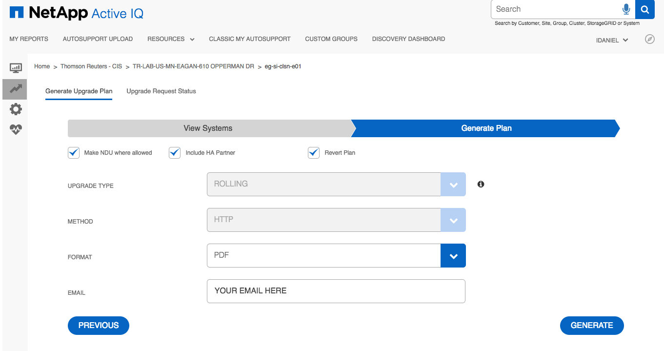

You should see a green status message at the bottom of the window as shown.

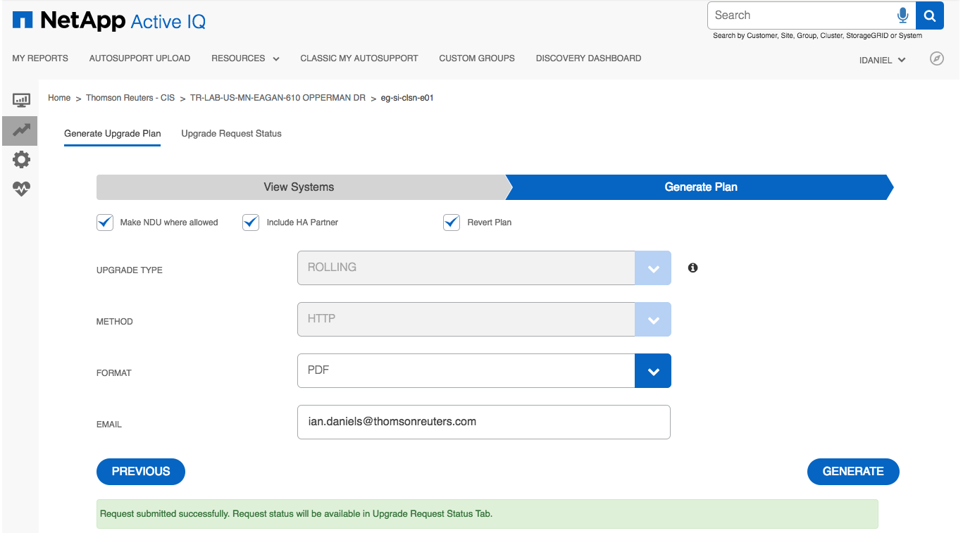

You can see the status by selecting the Upgrade Request Status tab.

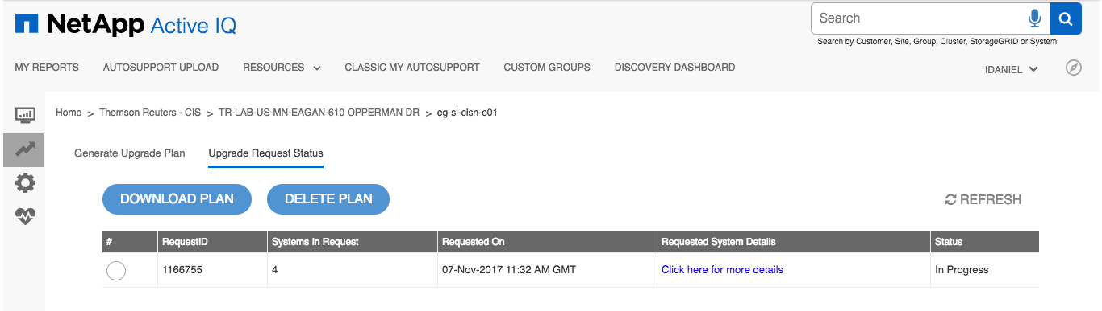

When it’s completed you will receive an email but can also download the plan via the site.

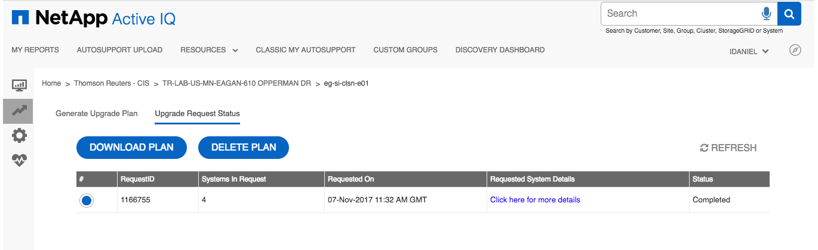

### ****Check Upgrade Advisor****

Read through Upgrade Advisor and check/remediate any issues that are flagged. You can double click the example to open the PDF file. One per node. Read all of them.



Once you feel all issues are remediated generate new ASUPs and then generate new Upgrade Advisors. Check these to ensure all issues are resolved.

# Upgrade Process (9.1P12)

## ****Description****

The upgrade process used in SI was ANDU, which forces a rolling upgrade.

**Note:** There are checks below which you could perform as pre-work but there is always a chance that something may happen after the pre-work so checks are part of the upgrade.

## ****Tasks****

### Download Code Onto All Nodes

::> cluster image package get -url http://10.220.179.83:8080/ONTAP/91P12_q_image.tgz

Software get http://10.220.179.83:8080/ONTAP/91P12_q_image.tgz started on node eg-si-clsn-e03-l01

Downloading package. This may take up to 10 minutes.

95% downloaded

There is no update/install in progress

Status of most recent operation:

Run Status: Working

Exit Status: Success

Phase: Download

Exit Message:

Processing Package.

Process package completed.

::> cluster image package show-repository

Package Version Package Build Time

---------------- ------------------

9.1P12 3/5/2018 11:39:31

9.1P7 8/14/2017 05:27:14

2 entries were displayed.

### Verify Storage Health

::*> storage disk show -broken

::> storage disk show -maintenance

Remediate any issues, wait for any maintenance to complete prior to upgrading.

### Check All Aggregates Are Online

Any aggregate that is offline needs to be fixed and online prior to upgrade.

::> aggr show -state !online

There are no entries matching your query.

### Check All Aggregates Have Enough Space

Any aggregate using more than 95% space needs to be fixed prior to upgrade

::> aggr show -percent-used >95

There are no entries matching your query.

### Check Auto Revert Settings

This command check the auto-revert setting and can be performed at any time. The setting is not altered if the lif is migrated. Make a note of the auto-revert settings prior to upgrade.

::> net int show -vserver * -lif * -fields auto-revert

### Enable Auto Revert If Required

::> net int modify {-role data -data-protocol !iscsi } -auto-revert true

### Check All Volumes Are Online

The following shows how to check for volumes that are not online. Any volumes returned will have a status of offline or restricted and must be dealt with before an upgrade is attempted (online them for the duration of the upgrade or remove if appropriate).

::*> vol show -state !online

(volume show)

Vserver Volume Aggregate State Type Size Available Used%

--------- ------------ ------------ ---------- ---- ---------- ---------- -----

cisesx-e0001

volume_post_test1

aggr1_data_h02

offline RW 1GB - -

ciststjms-e0001

test01 aggr1_data_h01

offline RW 100GB - -

mtt_test_vserver

InfDev00113 aggr1_data_h01

offline RW 200.5GB - -

orprod-iscsi-01

cb0000_wi_15142_07_info_snap_old

aggr1_data_h01

offline RW 25GB - -

si-8040-test-01

Image1 aggr1_data_l03

offline RW 10GB - -

si-8040-test-01

si_tst_nfs01_snap

aggr1_data_l04

offline RW 250GB - -

svm012abc cb0000_dme_msil_rename

aggr1_data_h01

offline RW 1GB - -

svm012abc jon_test_renamesuccess

aggr1_data_h01

restricted RW 25GB - -

svm789xyz dme_cDOT_mig_tstd2

aggr1_data_h02

restricted DP 1GB - -

svm789xyz dme_mig_cDOT_dst

aggr1_data_h02

restricted DP 1GB - -

svm789xyz ico_cdot_allocation_test_vol001

aggr1_data_h02

offline RW 1GB - -

svm789xyz ico_cdot_allocation_test_vol501

aggr1_data_h02

offline RW 18.75GB - -

12 entries were displayed.

### Check All Volumes Have Enough Space

Any volumes using more than 95% space should be adjusted to be below that threshold prior to upgrade (add space as appropriate).

**The volumes below are an example of this which would require remediation by adding more space prior to upgrading.**

::*> vol show -percent-used > 95

(volume show)

Vserver Volume Aggregate State Type Size Available Used%

--------- ------------ ------------ ---------- ---- ---------- ---------- -----

orprod-iscsi-01

cb0000_wi_15142_05_usr_snap

aggr1_data_h01

online RW 160GB 4.68GB 97%

orprod-iscsi-02

cb0000_wi_or_tsys_nosnap

aggr1_data_h01

online RW 68.26GB 1.99GB 97%

orprod-iscsi-02

cb0000_wi_or_usr_snap

aggr1_data_h01

online RW 634.5GB 993.2MB 99%

orprod-iscsi-03

cb0001_wi_winapp_usr_snap

aggr1_data_h01

online RW 152.6GB 1009MB 99%

orprod-iscsi-04

cb0000_wi_prj11504_usr_snap

aggr1_data_h02

online RW 152.6GB 1009MB 99%

si-8040-test-01

dng_test2 aggr1_data_l03

online RW 1GB 760KB 99%

6 entries were displayed.

### Check For Running Jobs

Check for running volume, aggregate or snapshot jobs.

::*> job show -state running\|queued -name !efficiency-DeDupe

Delete any jobs

::*> job delete -id *JOB_ID*

### Check Number of Snapshots is Less Than 20000 Per Node

set advanced

set -rows 0

volume snapshot show -node *<NODE_NAME>*

**Note:** There’s a count at the end of the output. More than 20000 per node means some will have to be deleted.

### Quiesce SnapMirrors If Used

::*> snapmirror quiesce -destination-path *

::*> snapmirror show -status !Quiesced

There are no entries matching your query.

### Check auto-giveback is disabled

::*> storage failover show -node * -fields auto-giveback

node auto-giveback

-------------- -------------

node-01 false

node-02 false

2 entries were displayed.

### Disable Auto-Giveback If Required On All Nodes

::*> storage failover modify -node *<NODE-NAME>* -auto-giveback false

### Disable Case Generation Prior To Upgrade For 4 Hours

autosupport invoke -node * -type all -message "MAINT=4h Starting_NDU"

**NOTE:** During this time, automatic case creation will suppressed at NetApp.

You can resume case creation at any time by executing the following command:

system node autosupport invoke -node * -type all -message MAINT=END

### Terminate CIFS Sessions

Before performing a nondisruptive upgrade or downgrade, you should identify and gracefully terminate any CIFS sessions that are not continuously available. Continuously available CIFS shares, which are accessed by Hyper-V clients using the SMB3 protocol, do not need to be terminated before upgrading or downgrading.

**(a) Identify any established CIFS sessions that are not continuously available:**

vserver cifs session show -continuously-available no

This command displays information about any CIFS sessions that have no continuous availability.

Each of the sessions identified by this command should be terminated before proceeding with the Data ONTAP upgrade or downgrade.

**Example**

::> vserver cifs session show -continuously-available no

Node: eg-si-clsn-e03-l02

Vserver: labsvm-e0035

Connection Session Open Idle

ID ID Workstation Windows User Files Time

---------- ------- ---------------- ---------------- --------- ---------------

1292849770 1 10.220.177.222 TLR\svcavcdot 0 58s

**(b) If necessary, identify the files that are open for each CIFS session that you identified:** vserver cifs session file show -session-id session_ID

Terminating CIFS Sessions

::> cifs session close -node eg-si-clsn-e03-l02 -vserver labsvm-e0035 -session-id 1

::> vserver cifs session show -continuously-available no

There are no entries matching your query.

### Validate Upgrade Package

::> cluster image validate -version 9.1P12

It can take several minutes to complete validation...

WARNING: There are additional manual upgrade validation checks that must be performed after these automated validation checks have completed successfully.

Refer to the Upgrade Advisor Plan or "Performing manual checks before an automated cluster upgrade" section in the "Clustered Data ONTAP Upgrade Express Guide" for the remaining manual validation checks that need to be performed before update.

Failing to do so can result in an update failure or an I/O disruption.

Pre-update Check Status Error-Action

--------------------- ---------- --------------------------------------------

Manual checks Warning Warning: Manual validation checks need to

be performed. Refer to the Upgrade Advisor

Plan or "Performing manual checks before an

automated cluster upgrade" section in the

"Clustered Data ONTAP Upgrade Express

Guide" for the remaining validation checks

that need to be performed before update.

Failing to do so can result in an update

failure or an I/O disruption.

Action: Refer to the Upgrade Advisor Plan

or "Performing manual checks before an

automated cluster upgrade" section in the

"Clustered Data ONTAP Upgrade Express

Guide" for the remaining validation checks

that need to be performed before update.

Overall Status Warning

2 entries were displayed.

### Estimate Upgrade Time

::> cluster image update -version 9.1P12 -estimate-only

Cluster               Items Requiring

Component             Updates           Estimated Duration

--------------------- ----------------- -----------------------------------

Node Updates          2                 77 minutes

Component Component ID Current Version Updated Version Estimated Duration

--------- ------------ --------------- --------------- ------------------

Node      sn-cis-clsp- 9.1P7           9.1P12          31 minutes

          s01-s01

Node      sn-cis-clsp- 9.1P7           9.1P12          31 minutes

          s01-s02

2 entries were displayed.

### Perform Upgrade

**Note:** You can reduce the time the upgrade waits after each takeover and giveback. The default is 8 minutes and we would recommend we stick with that. If you must change it use -stabilize-minutes

::> cluster image update -version 9.1P12

It can take several minutes to complete validation...

WARNING: There are additional manual upgrade validation checks that must be performed after these automated validation checks have completed successfully.

Refer to the Upgrade Advisor Plan or "Performing manual checks before an automated cluster upgrade" section in the "Clustered Data ONTAP Upgrade Express Guide" for the remaining manual validation checks that need to be performed before update.

Failing to do so can result in an update failure or an I/O disruption.

Pre-update Check Status Error-Action

--------------------- ---------- --------------------------------------------

Manual checks Warning Warning: Manual validation checks need to

be performed. Refer to the Upgrade Advisor

Plan or "Performing manual checks before an

automated cluster upgrade" section in the

"Clustered Data ONTAP Upgrade Express

Guide" for the remaining validation checks

that need to be performed before update.

Failing to do so can result in an update

failure or an I/O disruption.

Action: Refer to the Upgrade Advisor Plan

or "Performing manual checks before an

automated cluster upgrade" section in the

"Clustered Data ONTAP Upgrade Express

Guide" for the remaining validation checks

that need to be performed before update.

Overall Status Warning

2 entries were displayed.

Warning: Validation has reported warnings.

Do you want to continue? {y|n}: y

Starting update...

### Checking Upgrade Progress

The following commands show the various output you can see when checking progress as the upgrade works in the background.

::> cluster image show-update-progress

Estimated Elapsed

Update Phase Status Duration Duration

-------------------- ----------------- --------------- ---------------

Pre-update checks completed 00:10:00 00:00:02

Data ONTAP updates in-progress 01:17:00 00:01:49

Details:

Node name Status Status Description

-------------------- ----------------- --------------------------------------

eg-si-clsn-e03-l01 waiting

eg-si-clsn-e03-l02 in-progress Installing Data ONTAP software image.

3 entries were displayed.

::> cluster image show-update-progress

Estimated Elapsed

Update Phase Status Duration Duration

-------------------- ----------------- --------------- ---------------

Pre-update checks completed 00:10:00 00:00:02

Data ONTAP updates in-progress 01:17:00 00:02:29

Details:

Node name Status Status Description

-------------------- ----------------- --------------------------------------

eg-si-clsn-e03-l01 waiting

eg-si-clsn-e03-l02 in-progress Performing takeover operation.

3 entries were displayed.

::> cluster image show-update-progress

Estimated Elapsed

Update Phase Status Duration Duration

-------------------- ----------------- --------------- ---------------

Pre-update checks completed 00:10:00 00:00:02

Data ONTAP updates in-progress 01:17:00 00:05:01

Details:

Node name Status Status Description

-------------------- ----------------- --------------------------------------

eg-si-clsn-e03-l01 waiting

eg-si-clsn-e03-l02 in-progress Waiting for clients to stabilize

after takeover.

3 entries were displayed.

# Post-Upgrade Process (9.1P12)

## Description

After the upgrades are completed and all nodes are on ONTAP 9.1P12 we need to modify some of the configuration created by the upgrade process.

### Resume SnapMirror If Used

::> snapmirror resume -destination-path *

Operation succeeded: snapmirror resume for destination "sicifs-e0001:test_bip".

Operation succeeded: snapmirror resume for destination "silab-clbk-e01:c_mode_dest".

Operation succeeded: snapmirror resume for destination "silab-clbk-e01:test_bip".

Operation succeeded: snapmirror resume for destination "silab-clbk-e01:sv_07_cb0000_infra_virtual_saesxi_snap07".

Operation succeeded: snapmirror resume for destination "silab-clbk-e01:sv_14_cb0000_infra_virtual_saesxi_snap14".

Operation succeeded: snapmirror resume for destination "silab-clbk-iscsi-01:sv_14_cb0000_si_wi_fas2552_c_info_snap".

Operation succeeded: snapmirror resume for destination "silab-clbk-iscsi-01:sv_14_cb0000_si_wi_fas2552_c_usr_snap".

Operation succeeded: snapmirror resume for destination "silab-clbk-iscsi-01:sv_14_cb0000_wi_si_fas2552_a_info_snap".

Operation succeeded: snapmirror resume for destination "silab-clbk-iscsi-01:sv_14_cb0000_wi_si_fas2552_a_usr_snap".

Operation succeeded: snapmirror resume for destination "silab-clbk-iscsi-01:sv_14_cb0000_si_wi_fas2552_d_info_snap".

Operation succeeded: snapmirror resume for destination "silab-clbk-iscsi-01:sv_14_cb0000_si_wi_fas2552_d_usr_snap".

Operation succeeded: snapmirror resume for destination "silab-clbk-iscsi-01:sv_14_cb0000_wi_si_fas2552_b_info_snap".

Operation succeeded: snapmirror resume for destination "silab-clbk-iscsi-01:sv_14_cb0000_wi_si_fas2552_b_usr_snap".

Operation succeeded: snapmirror resume for destination "silab-clbk-mysql-01:sv_14_cb0000_si_mysqllab12d_s01mysql1_snap".

Operation succeeded: snapmirror resume for destination "silab-clbk-mysql-01:sv_14_cb0000_si_mysqllab13d_s01mysql1_snap".

Operation succeeded: snapmirror resume for destination "silab-clbk-mysql-01:sv_7_cb0000_si_mysqllab1d_s01mysql1_snap".

Operation succeeded: snapmirror resume for destination "silab-clbk-mysql-01:sv_7_cb0000_si_mysqllab2d_s01mysql1_snap".

Operation succeeded: snapmirror resume for destination "silab-clbk-e01:sv_14_cb0000_si_oralab14d_s01ora1_snap".

Operation succeeded: snapmirror resume for destination "silab-clbk-e01:sv_14_cb0000_si_oralab14d_s01oraadm1_snap".

Operation succeeded: snapmirror resume for destination "silab-clbk-e01:sv_14_cb0000_si_oralab15d_s01ora1_snap".

Operation succeeded: snapmirror resume for destination "silab-clbk-e01:sv_14_cb0000_si_oralab15d_s01oraadm1_snap".

Operation succeeded: snapmirror resume for destination "silab-clbk-e01:sv_14_cb0000_orf_2552_test_s01ora1_snap".

Operation succeeded: snapmirror resume for destination "silab-clbk-e01:sv_14_cb0000_orf_2552_test_s01oraadm1_snap".

Operation succeeded: snapmirror resume for destination "silab-clbk-e01:sv_14_cb0000_orf_2552_test2_s01ora1_snap".

Operation succeeded: snapmirror resume for destination "silab-clbk-e01:sv_14_cb0000_orf_2552_test2_s01oraadm1_snap".

25 entries were acted on.

### Ensure Auto-Giveback Is Still Disabled

::> storage failover show -fields auto-giveback

node auto-giveback

------------------ -------------

eg-si-clsn-e03-l01 false

eg-si-clsn-e03-l02 false

2 entries were displayed.

### Disable Auto-Giveback If Required

::> storage failover modify -auto-giveback false -node orf-lab2554-0*

Warning: Disabling auto-giveback under cluster HA configuration will prevent

the management cluster services from automatically going online under

alternating-failure scenarios. Do you want to disable auto-giveback?

{y|n}: y

2 entries were modified.

### RE-Home LIFs

Ensure all LIFs are on their home node post-upgrade.

::> net int show -role data -fields home-node ,is-home

::> net int revert *

(network interface revert)

1 entry was acted on.

### Disable Auto-Revert

You can use the supplied script to do this. By default we leave auto-revert off on data lifs.

::> net int modify {-role data -data-protocol !iscsi } -auto-revert false

# Scripts

## Description

During the upgrade a few scripts were used to make life easier they are attached here for reference.

### Enable/Disable Auto Revert

#!/bin/sh

WORKFILE=/tmp/`basename $0`.$$

CLUSTER=$1

ONOFF=$2

if [ ! -z "$CLUSTER" -a ! -z "$ONOFF" ];then

ssh admin@$CLUSTER 'set -rows 0 -showseparator ",";net int show -role data -data-protocol !iscsi -fields lif'| tail -n+5 | awk -v foo=$ONOFF -F, '{if(NF >3 ) printf "net int modify -vserver %s -lif %s -auto-revert %s\n",$1,$3,foo}' > $WORKFILE

cat $WORKFILE

else

echo

echo "Usage: `basename $0` Cluster_IP/Name true/false"

echo

fi

### Check DNS Accessible Pre-Upgrade

#!/usr/bin/perl

#

# Author : Dan Niedere

# Date : 2018.03.01

# Notes : Gathers all vservers on a given cluster and attempt to ping their first DNS server via the vservers lif

#

#

use strict;

use Getopt::Std;

#use diagnostics;

#use Data::Dumper;

my %opt;

my $cluster;

getopts('c:', \%opt);

if ($opt{c}) {

$cluster = $opt{c};

}

if ($cluster eq '') {

usage();

exit;

}

sub usage {

print "\nPing the primary and secondary dns server for all vservers via their associated lif\n";

print "\tUsage: $0 -c <cluster>\n\n";

}

my @out;

# Create vServerLif hash

@out = `ssh $cluster 'set -showseparator ","; network interface show -fields vserver,lif' |awk -F, '{print \$2","\$3}' |grep -Ev "server|Vserver" |sed "1d" |head -n -1`;

chomp(@out);

my %vServerLif = map { my ( $key, $value ) = split ','; $key => $value } @out;

# Create vServerDnsA

@out = `ssh $cluster 'set -showseparator ","; dns show -fields vserver,name-servers' |awk -F, '{print \$1","\$2}' |grep -Ev "vserver|Vserver|,,"`;

chomp(@out);

my %vServerDnsA = map { my ( $key, $value ) = split ','; $key => $value } @out;

# Create vServerDnsB

@out = `ssh $cluster 'set -showseparator ","; dns show -fields vserver,name-servers' |awk -F, '{print \$1","\$3}' |grep -Ev "vserver|Vserver|,,"`;

chomp(@out);

my %vServerDnsB = map { my ( $key, $value ) = split ','; $key => $value } @out;

# Loop through vServers in the vServerLif hash

foreach my $vServer ( keys %vServerLif ) {

# If A and B are empty, vServer has no DNS servers

if ( $vServerDnsA{$vServer} eq '' && $vServerDnsB{$vServer} eq '') {

print "$vServer($vServerLif{$vServer} -> $vServerDnsA{$vServer},$vServerDnsB{$vServer}): ";

print "No DNS servers configured\n\n";

next;

}

# Ping DNSa via vServer LIF

@out = `ssh $cluster net ping -lif-owner $vServer -lif $vServerLif{$vServer} -destination $vServerDnsA{$vServer} -wait-response 2000 |grep -v "network ping"`;

print "$vServer($vServerLif{$vServer} -> $vServerDnsA{$vServer})(Primary): @out";

# Ping DNSb via vServer LIF

@out = `ssh $cluster net ping -lif-owner $vServer -lif $vServerLif{$vServer} -destination $vServerDnsB{$vServer} -wait-response 2000 |grep -v "network ping"`;

print "$vServer($vServerLif{$vServer} -> $vServerDnsB{$vServer})(Secondary): @out";

}